Procedure to Install UV Ring System on 1800 Machine, new 1800, 1500

# Purpose

## Intended audience

Production, engineering, integration, sales & marketing personnel

# Installation Procedure for 1800 Machine

## Contents of UVR installation kit

|  |  |  |  |
| --- | --- | --- | --- |
| Qty | Cat No | Part |  |
| 1 | ASM-01476A | UVR HEAD | 1 |
| 1 | ASM-01479A | DRIVER | 2 |
| 1 | PRT-01650A | BRACKET UV HEAD ASSY | 3 |
| 3 | SCR-40076 | SCREW SEMS M4X8 | 4 |
| 3 | NUT-001000 | NUT,SLOT,M4,MULTI AXIS,ST | 5 |
| 1 | PRT-30891A | ALIGNMENT TOOL | 6 |
| 1 | MA-01-5257 | CABLE-CONTROLLER-UVR | 7 |
| 1 | MA-01-5258 | CABLE-UVR CONTROLLER TO BECKHOFF | 8 |
| 1 | MA-01-5259 | CABLE-UVR POWER | 9 |
| 1 |  | 50cm Blake wire 20AWG | 10 |
| 4 | CLS-M4-2 | Self- clinching nuts | 11 |
| 4 | SCR-40076 | SCREW SEMS M4X8 | 12 |
| 20 | 125X2.5mm | Cable tie | 13 |

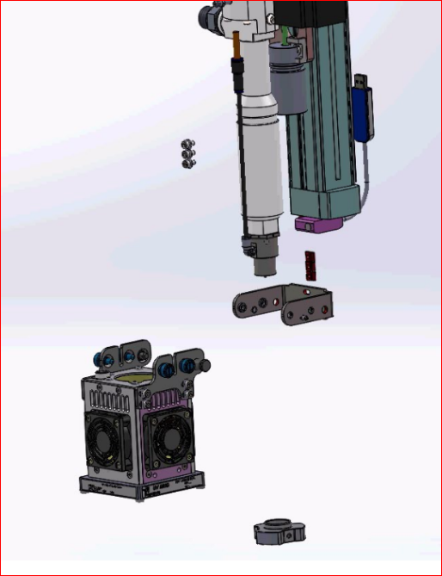



## Installation Procedure

1. Turn off the machine and disconnect the power to it.
2. Disassemble the old UV lamp, including the chassis

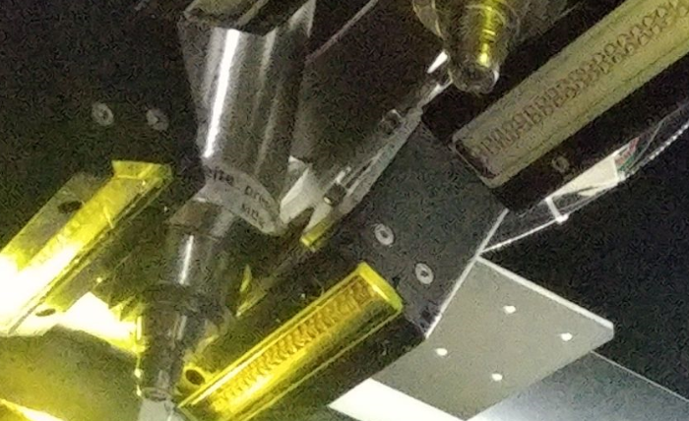

1. Connect the new clamp to the [Z axis] using 3 screws (don’t tighten)

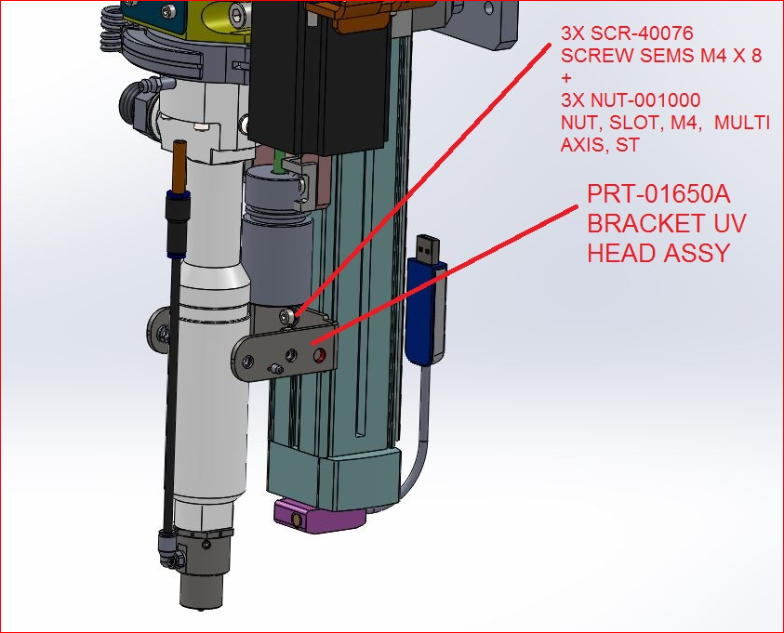

1. Connect the UV lamp to the clamp using 2 pins and 4 screws

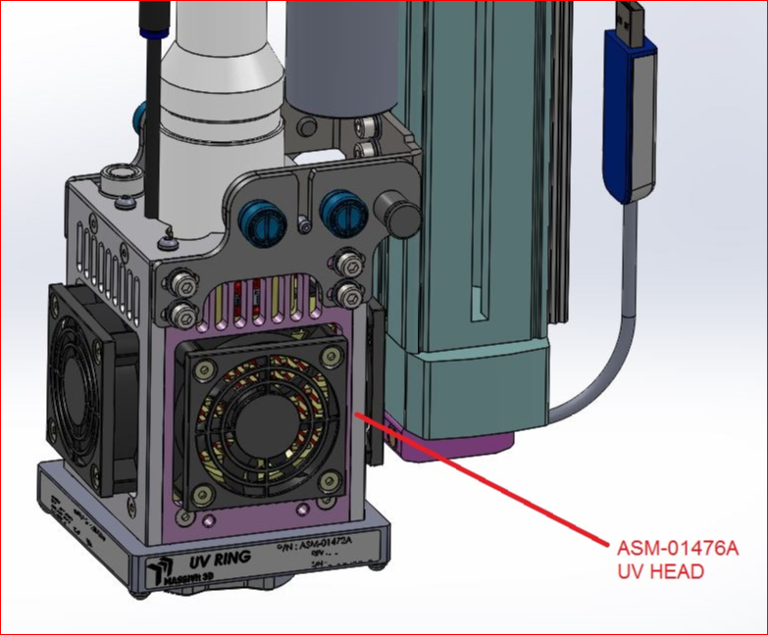

1. Using the jig, adjust the UV lamp to the correct height in the center of the [?]
2. The correct height is 15 mm from the glass to the bottom of the tip

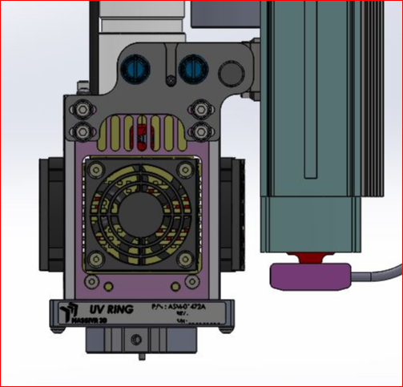

1. Tighten the three (3) bracket screws
2. Thread the cable (12-strand) through the [] until it reaches the electrical cabinet.
3. Connect the round electrical connector {?] to the UV lamp by turning it lightly until [??], and then pressing the case down.

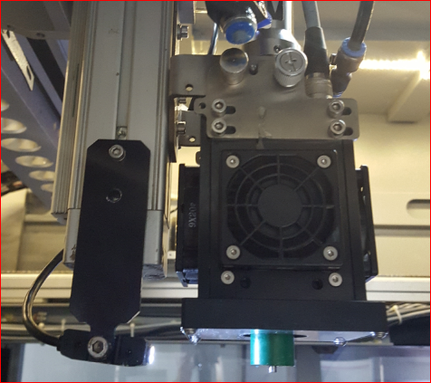

bracket

Round connector

1. Connect the 15-pin D connector to the driver [box] in the old 1800 electrical cabinet as follows:.
2. The driver [box] is installed in the electrical cabinet near the top covering (on the panel with two fans)
3. Connect the 12-pin D-type connector to the Driver.
4. Route all cables in harnesses

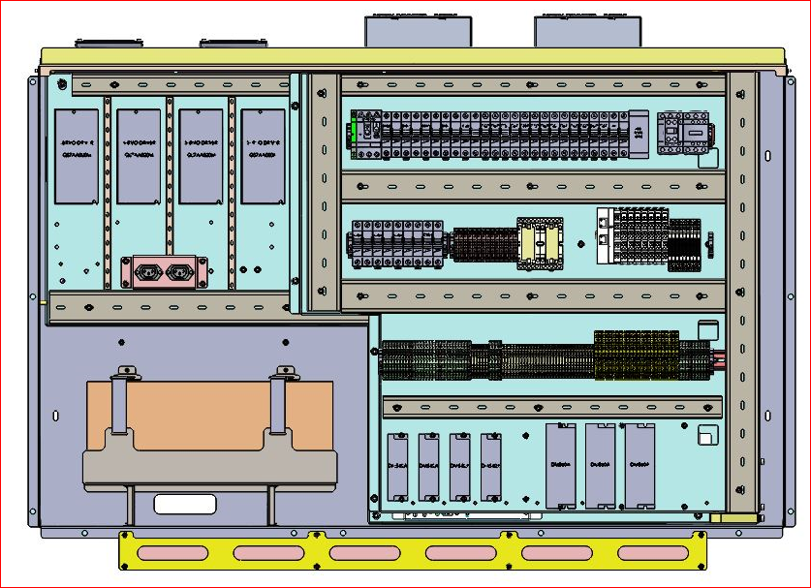

1. Connect the 25-pin cable (MA-01-5258) to the main left box [?], as follows, and lay the cable [?]
2. TB A03 and A04 are in the left box:
3. Connect INTENSITY 1 and INTENSITY 2 to A03
4. Connect INTENSITY 3 and INTENSITY 4 to A04
5. Connect ENABLE 1 and ENABLE 2 to D03
6. Connect ENABLE 3 and ENABLE 4 to D04
7. Connect the 25-pin cable (MA-01-5258) to the main right box as follows:
8. TB A01 and A02 are in the right box
9. Connect INTENSITY 1 and INTENSITY 2 to A01
10. Connect INTENSITY 3 and INTENSITY 4 to A02
11. Connect ENABLE 1 and ENABLE 2 to D01
12. Connect ENABLE 3 and ENABLE 4 to D02
13. Insulate and tie up the 4 READY strands in each of the MA-01-5258
14. Leave the TEMP strand exposed (at end of the installation, insulate it)
15. Connect the power supply to the power connections in the old 1800 cabinet as follows:
16. Connect the power cable MA-01-5259 to the DRIVER box, and pass the cable through the channel towards relay R13
17. Connect the RED strand on the right side to pin 24 on relay R13
18. Connect the RED strand on the left side to pin 34 on relay R13
19. Insulate the WHITE strand and tie it up
20. Connect the BLACK strand to TB-48
21. Connect the BLACK strand AWG20 to short between TB 48 and TB 24
22. Connect a digital voltmeter between the fasteners, and confirm 48V, and also confirm 48V between pin 24 in relay R13 on the right side and pin 34 in relay R13 on the left side
23. Adjust the small screw [?] to adjust the 48V power voltage of the UV to 52V
24. Power supply PS2 is for the right head, and PS1 for the left.
25. Connect the 15-pin D-type connector to the DRIVER box in the electrical cabinet of the new 1800 as follows:
26. In the electrical cabinet opposite the power panel at the top, approx. 10cm to the right of the MOONS DRIVER, place the DRIVER card box (with the small side upwards), and affix it to the metal, parallel to the MOONS DRIVER (check that the power supply connector is on top).
27. Mark the locations of the holes, and drill four (4) 4mm holes in the wall.
28. Ensure that no debris from the drilling enters the computer or any other electrical device.
29. Thread the holes for 4M screws, and connect the box with 4 screws and washers.
30. Connect the 12-pin D-type connector to the DRIVER box.
31. Channel all the cables through the channels

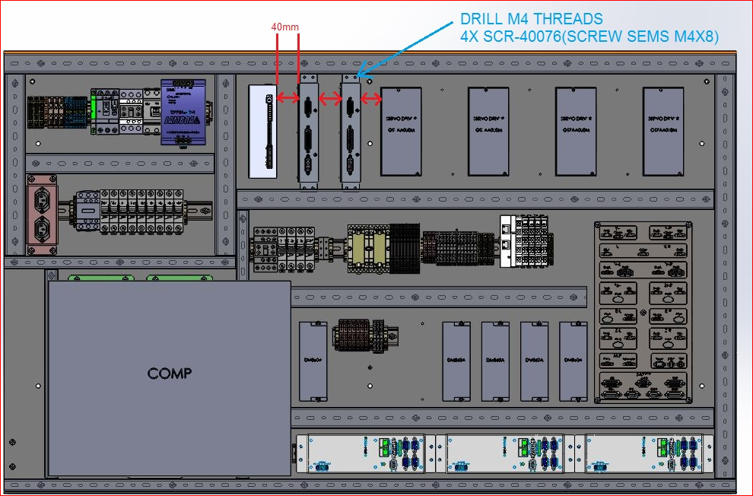

1. Connect the 25-pin cable (MA-01-5258) to the main left box [?], as follows, and lay the cables through the channels
2. TB A03 and A04 are in the left box:
3. Connect INTENSITY 1 and INTENSITY 2 to A03
4. Connect INTENSITY 3 and INTENSITY 4 to A04
5. Connect ENABLE 1 and ENABLE 2 to D03
6. Connect ENABLE 3 and ENABLE 4 to D04
7. Connect the 25-pin cable (MA-01-5258) to the main right box as follows:
8. TB A01 and A02 are in the right box
9. Connect INTENSITY 1 and INTENSITY 2 to A01
10. Connect INTENSITY 3 and INTENSITY 4 to A02
11. Connect ENABLE 1 and ENABLE 2 to D01
12. Connect ENABLE 3 and ENABLE 4 to D02
13. Insulate and tie up the 4 READY strands in each of the MA-01-5258
14. Leave the TEMP strand exposed (at end of the installation, insulate it)
15. Connect the power supply to the power connections in the new 1800 cabinet as follows:
16. Connect the power cable MA-01-5259 to the DRIVER box, and pass the cable through the channel towards relay R13
17. Connect the RED strand on the right side to pin 24 on relay R13
18. Connect the RED strand on the left side to pin 14 on relay R13
19. Insulate the WHITE strand and tie it up
20. Connect the BLACK strand to TB-48RTH
21. Connect the BLACK strand AWG20 to short between TB-48RTH and TB-24
22. Connect a digital voltmeter between the fasteners, and confirm 48V, and also confirm 48V between pin 24 in relay R13 on the right side and pin 14 in relay R13 on the left side
23. Adjust the small screw [?] to adjust the 48V power voltage of the UV to 52V
24. Power supply PS48R is for the right head, and PS48L for the left.
25. Verify the installation:
26. Reconnect power to the machine, turn on the computer and start the program. Close the doors and check that the system works correctly.
27. Connect a digital voltmeter between the TEMP wire in cable MA-01-5258 and the -24V or -48V.
28. If the reading is about 4V, indicating room temperature (20-25°), this indicates the system is receiving correct voltages.
29. Close the doors and turn on the UV system to 50%, and check that all the LED lights in the two rings of the UVR are lit.
30. Increase the intensity to 100% and check that the intensity increases.
31. Reduce the intensity to 10% and check that the intensity is reduced to the minimum.
32. Reduce the intensity to 0% and check that all the LED lights are off.
33. If the above steps worked as described, the system is working correctly.
34. Test scanning and the UV intensity using a UV measuring device.
35. This test will help confirm that there are no obstructions that will interfere with printing and that the UV intensity is correct.
36. To check UV in production or service use the Ophir device.
37. To check UV in a Massivit device, use document WI-02-011

# Installation Procedure for 1500 Machine

## Contents of the UVR installation kit for 1500

|  |  |  |  |  |
| --- | --- | --- | --- | --- |
| Qty | Cat, No. | | Part | # |
| 1 | ASM-01476A | | UVR HEAD | 1 |
| 1 | ASM-01479A | | DRIVER | 2 |
| 1 | PRT-01650A | | BRACKET UV HEAD ASSY | 3 |
| 3 | SCR-40076 | | SCREW SEMS M4X8 | 4 |
| 3 | NUT-001000 | | NUT,SLOT,M4,MULTI AXIS,ST | 5 |
| 1 | PRT-30891A | | ALIGNMENT TOOL JIG | 6 |
| 1 | MA-01-5257 | | CABLE-CONTROLLER-UVR | 7 |
| 1 | MA-01-5258 | | CABLE-UVR CONTROLLER TO BECKHOFF | 8 |
| 1 | MA-01-5259 | | CABLE-UVR POWER | 9 |
| 1 |  | | 50cm Blake wire 20AWG | 10 |
| 4 | CLS-M4-2 | | Self- clinching nuts | 11 |
| 4 | SCR-40076 | | SCREW SEMS M4X8 | 12 |
| 20 | 125X2.5mm | | Cable tie | 13 |
| 1 | PRT-30670A | UVR 1500 Z-PROBE HOLDER | | 14 |
| 4 | SCR-00410 | SOCKT HEAD CAP SCREW DIN912 M4X10 | | 15 |

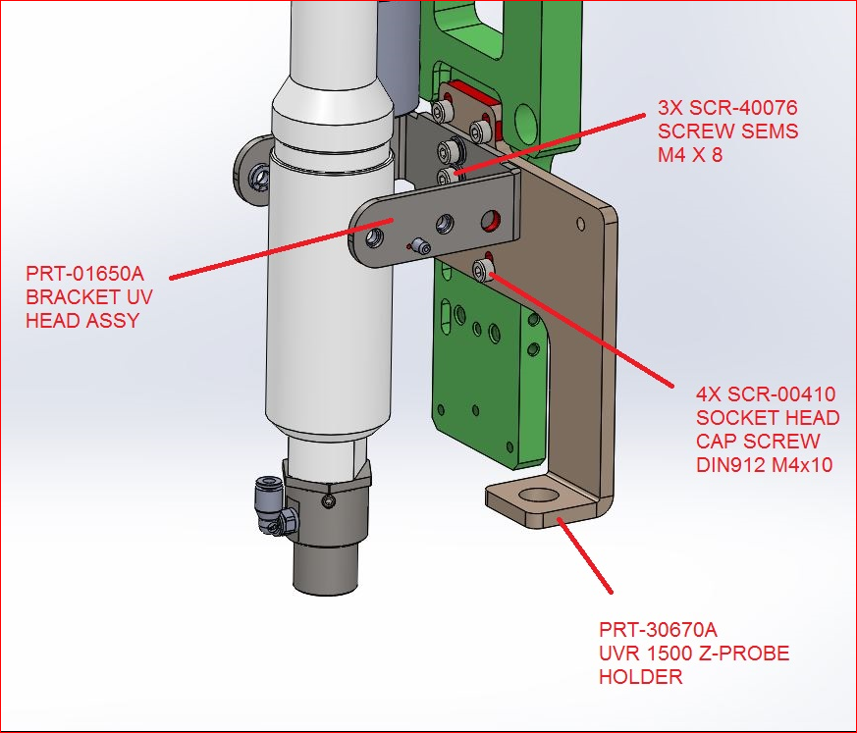



## Installation Procedure

1. Turn off the machine and disconnect the power from it.
2. Disassemble the UV lamp, including the chassis.



1. Connect the new clamp to the small Z-axis using the [adaptor] that is fastened to the Z-axis by three screws, and the clamp that is fastened by three screws and washers.

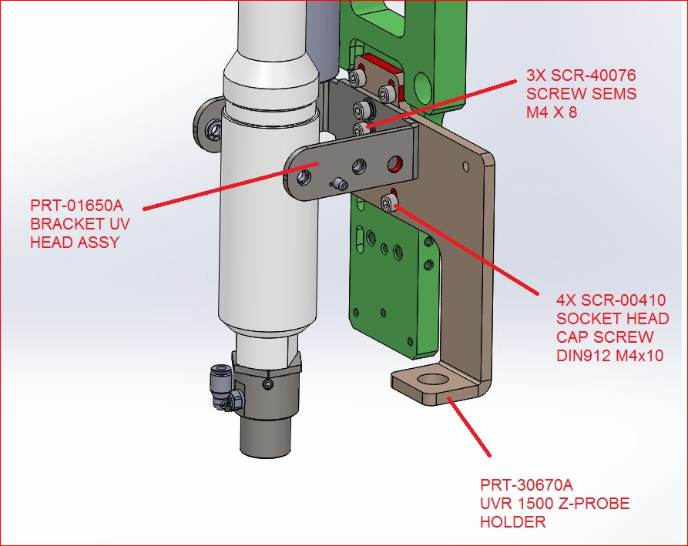

1. Connect the UVR to the clamp using two (2) pins and four (4) fixed screws.

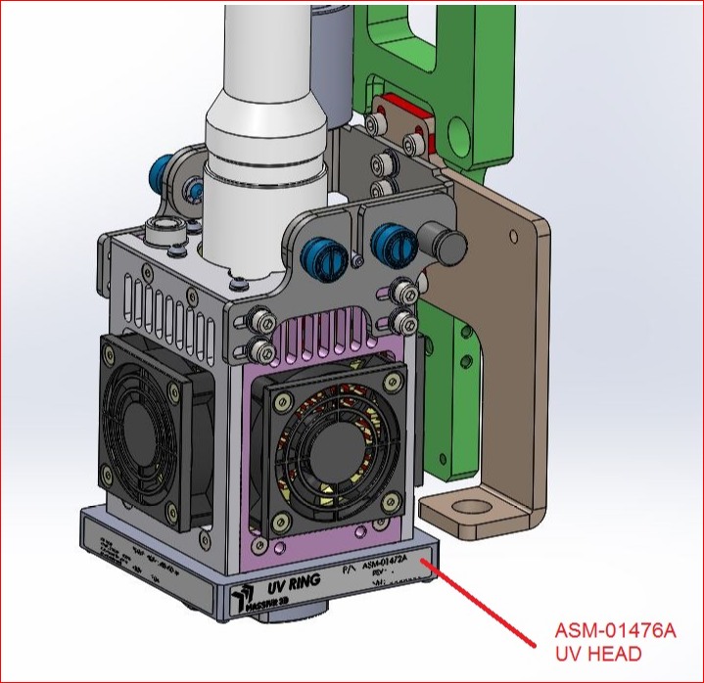

1. Using the jig, move the UVR lamp to the correct height in the center of the [?]
2. The correct height is 15mm from the glass to the lower edge of the tip.

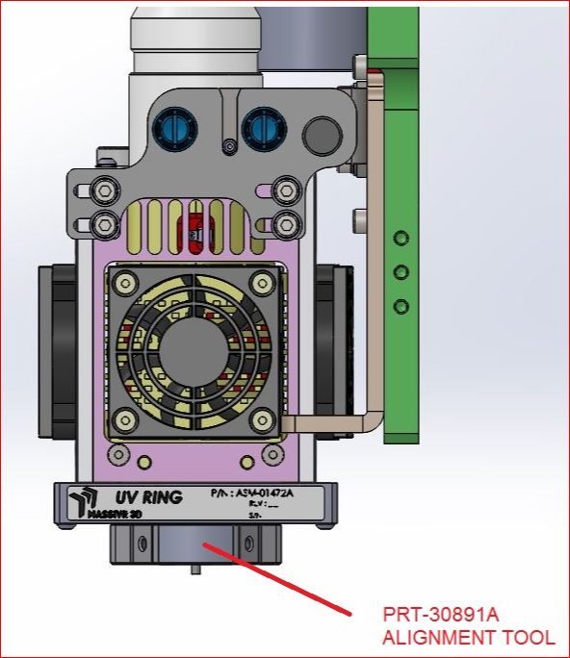

1. Tighten the three (3) screws of the clamp.
2. Thread the 12-strand MA-01-5257 cable through [?] until the electrical cabinet.
3. Connect the round electrical connector {?] to the UV lamp by turning it lightly until [??], and then pressing the case down



bracket

Round connector

1. Connect the 15-pin D connector to the driver [box] in the 1500 electrical cabinet as follows:
2. Install the driver box in the electrical cabinet near the top of the electrical board on the right side of the connector panel (with the narrow side upwards) and affix it to the electrical board (check that the power connector is on the upper side).
3. Mark the locations of the holes, and drill four (4) 4mm holes in the wall.
4. Ensure that no debris from the drilling enters the computer or any other electrical device.
5. Thread the holes for 4M screws.
6. Connect the Driver card box with 4 SEMSM4X8 screws (SCR-40076)
7. Connect the 12-pin D-type connector to the DRIVER box
8. Channel all the cables through the channels

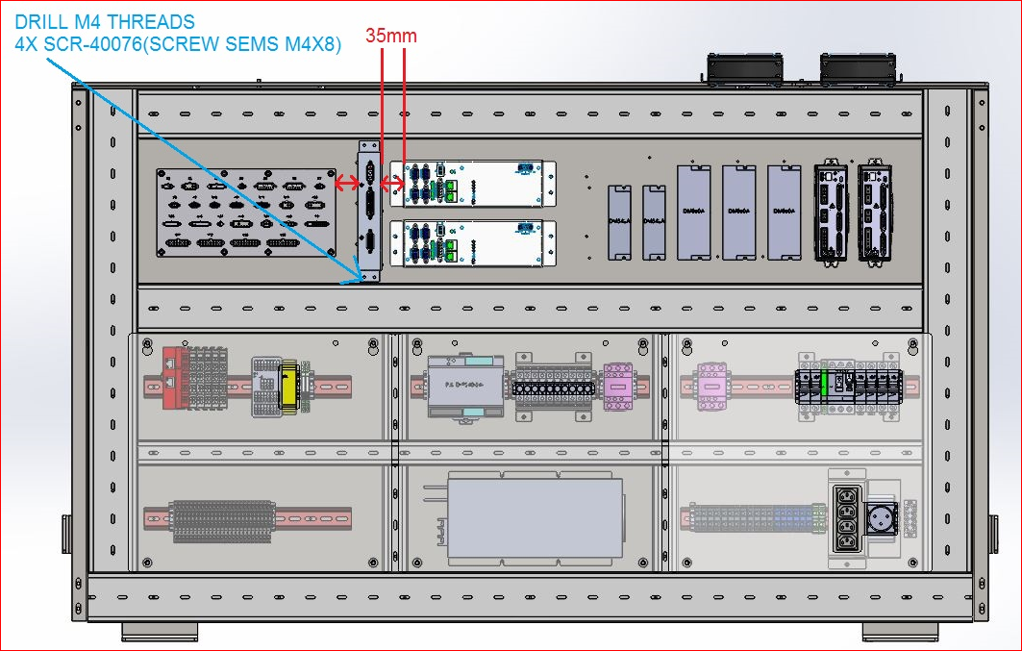

1. Connect the 25-pin cable (MA-01-5258) to the driver box, as follows, and lay the cable along the chann el[?] to the Beckoff [?]
2. Connect wires INTENSITY 1 and INTENSITY 2 to port AI1 of the EL4008 unit
3. Connect wires INTENSITY 3 and INTENSITY 4 to port AI1 of the EL4008 unit
4. Connect wires ENABLE 1 and ENABLE 2 to port DO6 of the EL2809 unit
5. Connect wires ENABLE 3 and ENABLE 4 to port DO7 of the EL2809 unit
6. Connect wire READY 1 to port DI1.13 of the EL1809 unit
7. Connect wire READY 2 to port DI1.14 of the EL1809 unit
8. Insulate and tie up the 4 READY strands in each of the MA-01-5258
9. Leave the TEMP strand exposed
10. Connect the power supply to the power connections of the 1500 electrical cabinet as follows:
11. Connect the power cable MA-01-5259 to the DRIVER box, and pass the cable through the channel towards the fuses (F7)
12. Connect the RED strand to the outgoing pin of fuse F7
13. Insulate the WHITE strand and tie it up
14. Connect the BLACK strand to 48 of the 48V supply
15. Connect the BLACK strand AWG20 to short between 48 of the 48 V supply and 24 of the 24V supply
16. Connect a digital voltmeter between the 48V clamps and F7, and check the voltage is 48V
17. Verify the installation:
18. Connect a digital voltmeter between the TEMP wire in cable MA-01-5258 and the -24V or -48V
19. If the reading is about 4V, indicating room temperature (20-25°), this indicates the system is receiving correct voltages.
20. Close the doors and turn on the UV system to 50%, and check that all the LED lights in the two rings of the UVR are lit.
21. Increase the intensity to 100% and check that the intensity increases.
22. Reduce the intensity to 10% and check that the intensity is reduced to the minimum.
23. Reduce the intensity to 0% and check that all the LED lights are off.
24. If the above steps worked as described, the system is working correctly.
25. Test scanning and the UV intensity using a UV measuring device.
26. This test will help confirm that there are no obstructions that will interfere with printing and that the UV intensity is correct.
27. To check UV in production or service use the Ophir device.
28. To check UV in a Massivit device, use document WI-02-011



